**INDIAN SIGN LANGUAGE TRANSLATOR**

**OBJECTIVE AND SCOPE OF THE PROJECT**

Sign language is a visual language that is used by deaf people as their mother tongue. Unlike acoustically conveyed sound patterns, sign language uses body language and manual communication to fluidly convey the thoughts of a person. It is achieved by simultaneously combining hand shapes, orientation and movement of the hands, arms or body, and facial expressions.

It can be used by a person who has difficulties in speaking or by a person who can hear but could not speak and by normal people to communicate with hearing disabled people. As far as a deaf person is concerned, having access to a sign language is very important for their social, emotional and linguistic growth. Sign language should be recognized as the first language of deaf people and their education can be proceeded bilingually in the national sign language as well as national written or spoken language.

But it is very difficult to establish communication between a deaf/mute person and a normal person who don’t know the sign language and this is nothing that we can just learn a day. As a result these disabled persons faced a lot of problems all around in establishing communication.  
  
As a human we should always help but because of this communication gap we are not able to do that the available solution are using ASL (American Sign Language) which mostly used there and every country as their own like in India we have ISL(India Sign Language) but very few percentage of persons knows it as a result we are facing these communication gap.

**Sign Language Translator:**

A application which will help people who don’t know the sign language in communicating with these people. Not only able to communicate them it will support Hindi which is widely spoken all over the country and also other regional languages like Marathi, Bengali, etc.

It is integrated with GTTS to let user operate it with ease using voice commands. Moreover it would show a GIF visualization to let the other person better through Sign Language and body motions. As Sign language is not only about Hand movement.

ISL signs can be generally classified into three classes: One handed, two handed, and non-manual signs. One handed signs and two handed signs are also called manual signs where the signer uses his/her hands to make the signs for conveying the information. Non Manual signs are generated by changing the body posture and facial expressions.

This system is to help hearing impaired people in India interact with others as it translates English text to Sign language.

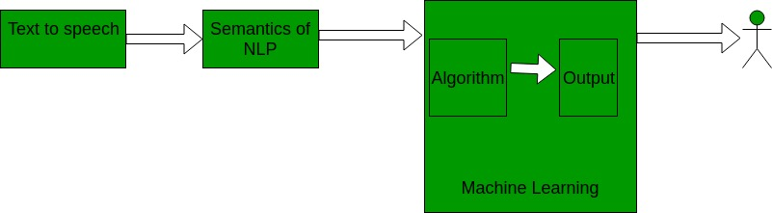

**Goals**  
1. To provide information access and services to deaf people in Indian sign language.  
2. To develop a scalable project which can be extended to capture whole vocabulary of ISL through manual and non manual signs

3. To let people get aware about the Sign Language

4. To let people learn about Sign Language

**Available Solutions**

1. Master Sign Language

2. Indian Sign Language Translator

3. Sign Language ASL

4. Spread Signs

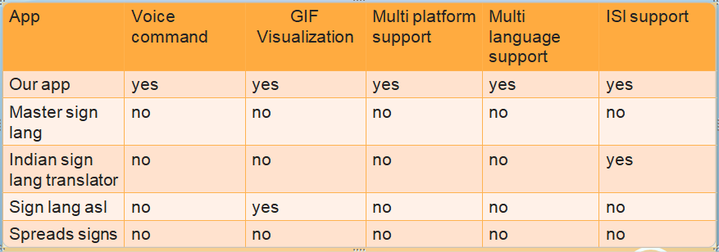

**Why are we better than above?**

All the above apps are reputed application on play store with good number of downloads and average score what we find vulnerable in them is that many of them don’t support Indian Sign Language and the one which supports its only provide predefined words

So here are some key points how are we different from them as mentioned in above comparison charts

* Voice Command
* GIF Visualization
* ISL Support
* Regional Language Support

**Technical Specifications**

This project is based on converting the audio signals received to text using speech to text api (python modules or google api) and then using the semantics of Natural Language Processing to breakdown the text into smaller understandable pieces which requires Machine Learning as a part data sets of predefined sign language are used as the input so that the software can use artificial Intelligence to display the converted audio into the sign language.

**AI (Artificial Intelligence)** – It is the theory and development of computer systems to be able to perform tasks normally requiring human intelligence, such as visual perception, speech recognition, decision-making, and translation between languages.

**ML (Machine Learning)** – Machine learning is the science of getting computers to act without being explicitly programmed. The Inputs are given as data sets by which the system learns and tries to give the best possible outcome to the user.

**NLP (Natural Language Processing) –** It is the application of computational techniques to the analysis and synthesis of natural language and speech.

**Platform Used:**  
Software Implemented through Python  
A desktop application is implemented using python programming language. Python  
includes libraries such as pyaudio to convert speech to text.  
– Python 2.7.x is preferred.  
– Pycharm community edition compiler.  
– Operating System – Ubuntu (Linux).  
– ISL/ASL data sets from google.

**Methodology**  
1. Audio input on a Personal Digital Assistant(PDA) using python PyAudio module.  
2. Conversion of audio to text using Google Speech API.  
3. Dependency parser for analysing grammatical structure of the sentence and establishing relationship between words.  
4. ISL Generator: ISL of input sentence using ISL grammar rules.  
5. Generation of Sign language with signing Avatar.

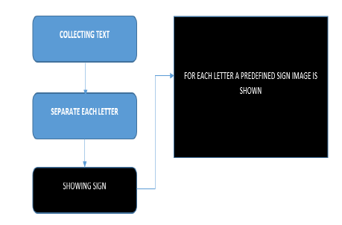Figure 1: Above figure showing how text is converted to signs

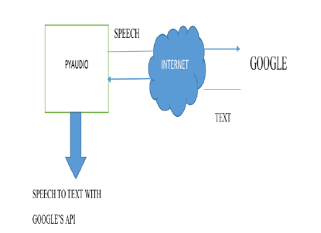Figure 2: Above figure showing how PyAudio will work

**Future Scope**

1. Since deaf people are usually deprived of normal communication with other people, they have to rely on an interpreter or some visual communication. Now the interpreter can not be available always, so this project can help eliminate the dependency on the interpreter.

2. The system can be extended to incorporate the knowledge of facial expressions and body language too so that there is a complete understanding of the context and tone of the input speech.

3. A mobile and web based version of the application will increase the reach to more people.

4. Integrating hand gesture recognition system using computer vision for establishing 2-way communication system.